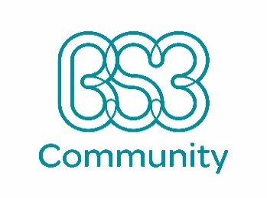

**Job Vacancy – Early Years Assistant - Lunch Time Assistant**

**You** are looking for your next career step, a new challenge, and a job with a purpose.

**Due to expansion, we** are looking for Lunch Time Assistant to join our growing Early Education team at our OFSTED Outstanding nursery based in one of our Centres.

**About us:** We are committed to supporting our team members’ professional development and can offer the right candidate a fantastic opportunity in a unique childcare setting. We are a charity and run as a community business and we are proud to say that we reinvest our profits back into developing the community of the children we look after.

**About you and the role:** You are motivated, reliable and have a positive attitude and approach to work with children in an OFSTED Outstanding nursery. Your role involves supporting the smooth running of the nursery during lunch time and assisting with activities and experiences for children. Some previous related experience is desirable including food hygiene training, however we would be willing to offer training and support to the right candidate.

Please contact [hr@bs3community.org.uk](mailto:hr@bs3community.org.uk) for an application.

**SAFEGUARDING NOTE**: As this role is working in a “regulated activity” according to the Safeguarding Vulnerable Groups Act 2006, the successful applicant will require an Enhanced Disclosure and Barring Certificate (DBS).

To successfully fulfil our vision (aim) we need a truly diverse workforce that reflects the society we serve. We therefore welcome and encourage applications from anyone who meets the job requirements. We are actively seeking people with a wide variety of backgrounds and experiences in terms of ethnicity, culture, and religion, LGBTQ+ candidates, people from any socio-economic background, those who consider themselves to be or have been diagnosed as neurotypical or have psychological or physical conditions or levels of ability that may require adaptations or support.

**Hours:** 15 hours per week

**Rate of Pay:** £18,770.40 per annum (£9.00 per hour) (15-hour work week) plus benefits including subsidised childcare & training and development opportunities.

**Closing Date:** 14.05.2021

**Start Date:** May / June 2021



